**ASSIGNMENT 4 (COURIER MANAGEMENT)**

Task 1: Select,Where

Solve the following queries in the Schema that you have created above

1. List all customers

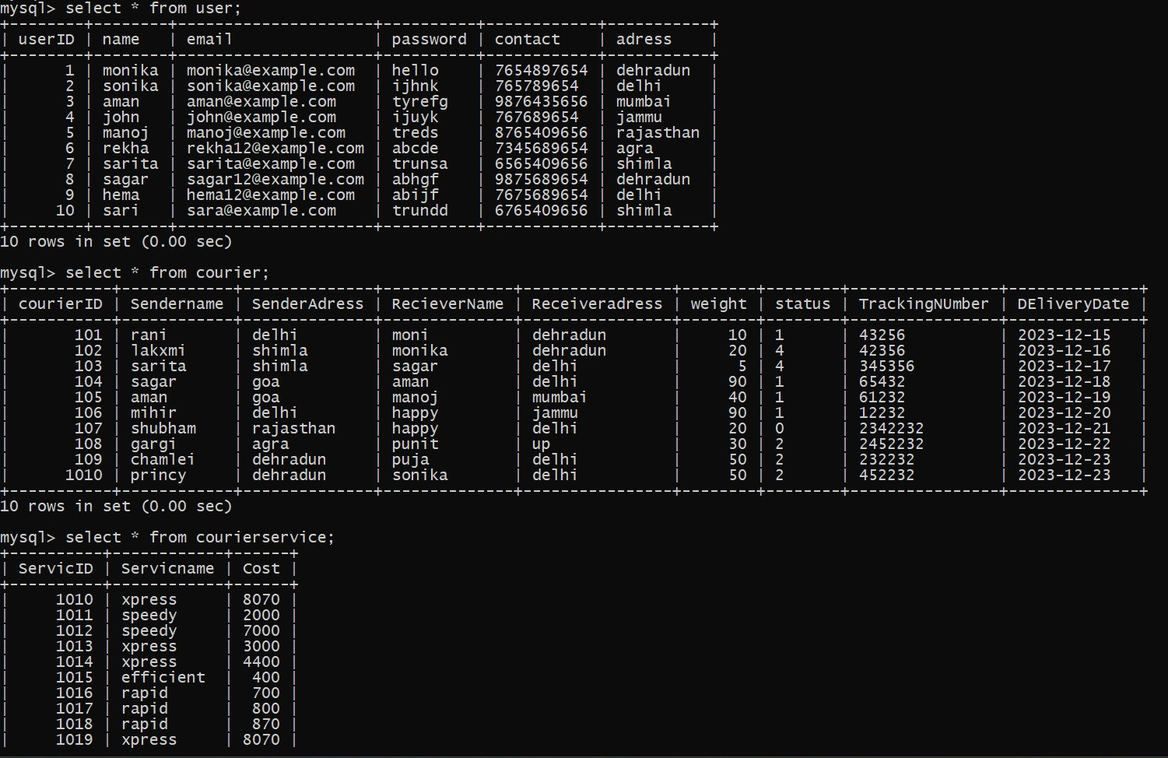

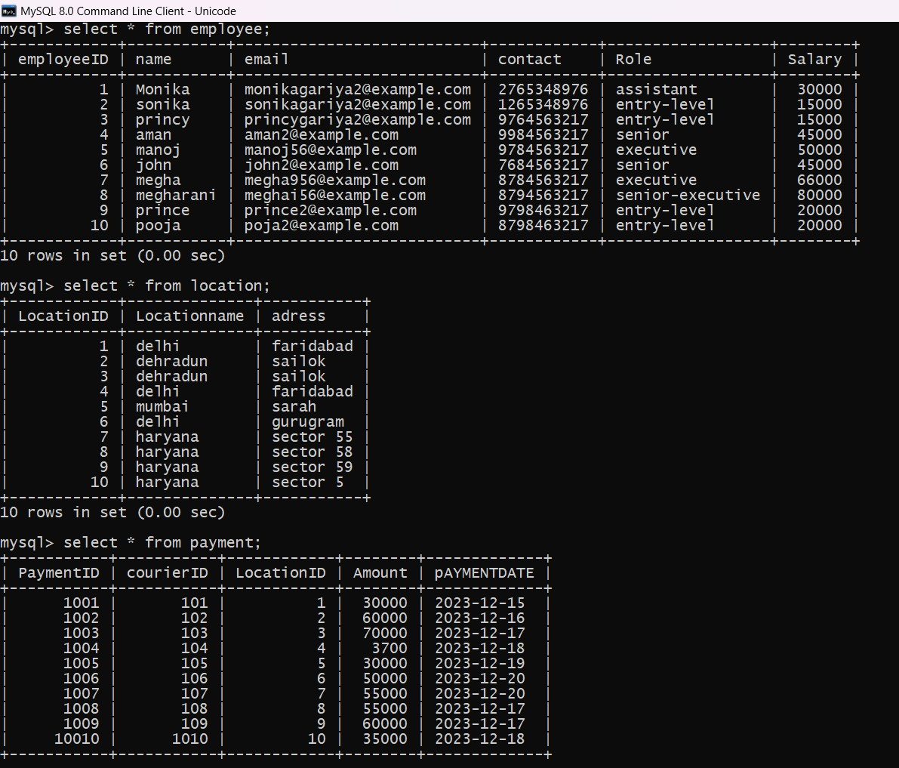

1. List all orders for a specific customer

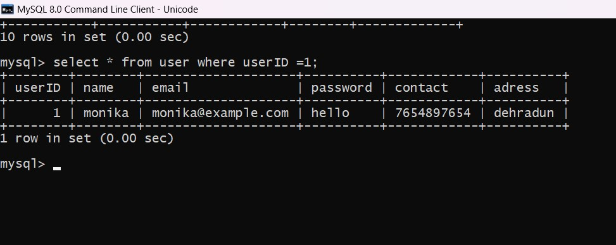

3.List all couriers:

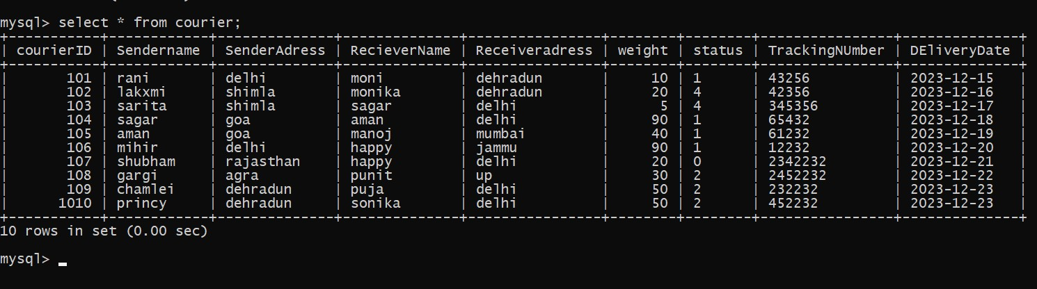

4. List all packages for a specific order:

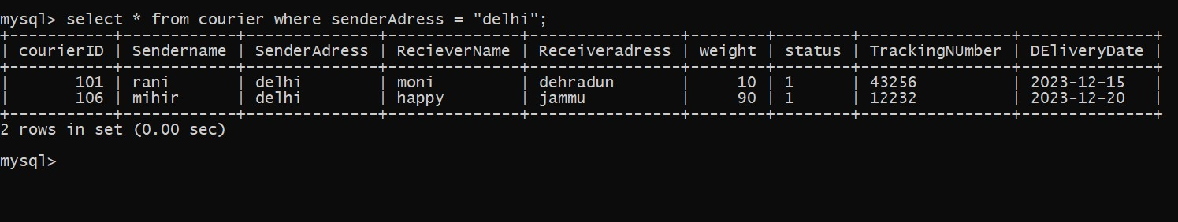

**5.** List all deliveries for a specific courier



6. List all undelivered packages:

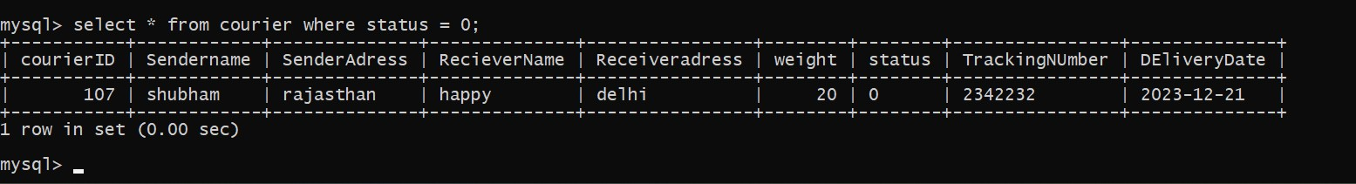

7.  List all packages that are scheduled for delivery 2023-12-23:

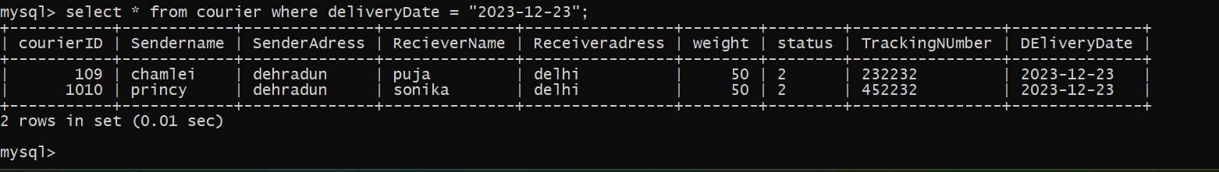

8. List all packages with a specific status

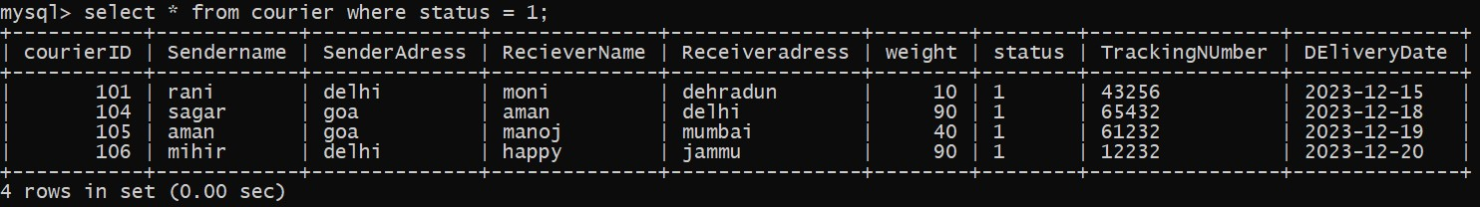

9. Calculate the total number of packages for each courier.



10. Find the average delivery time for each courier

11.List all packages with a specific weight range:

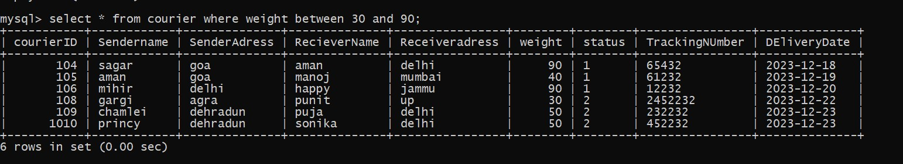

12. Retrieve employees whose names contain 'John'

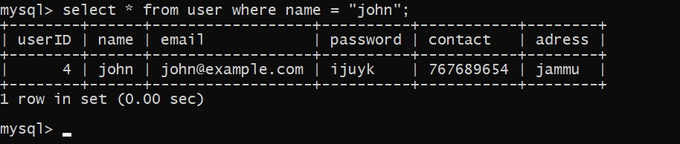

13.  Retrieve all courier records with payments greater than $50.

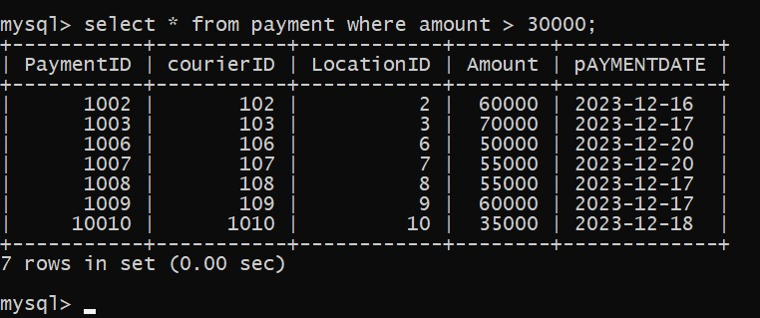

Task : GroupBy, Aggregate Functions, Having, Order By, where

14. Find the total number of couriers handled by each employee

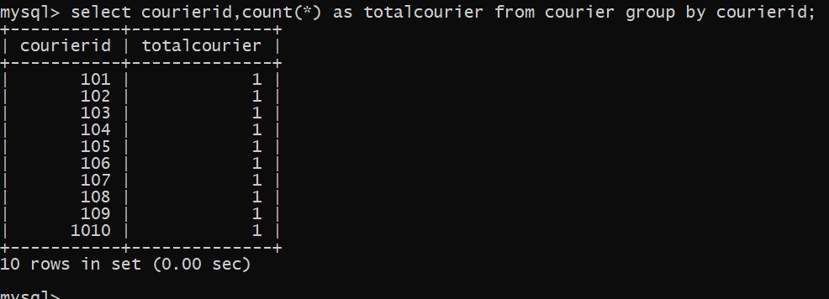

15. Calculate the total revenue generated by each location

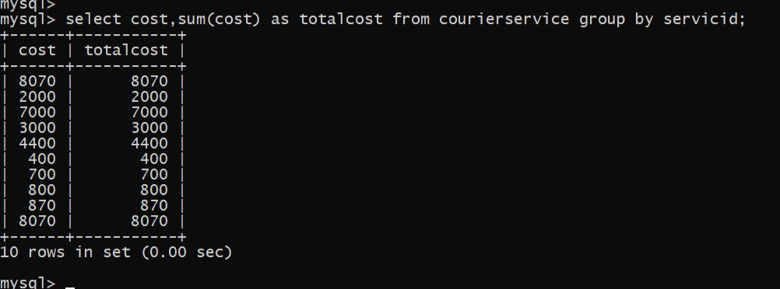

16. Find the total number of couriers delivered to each location

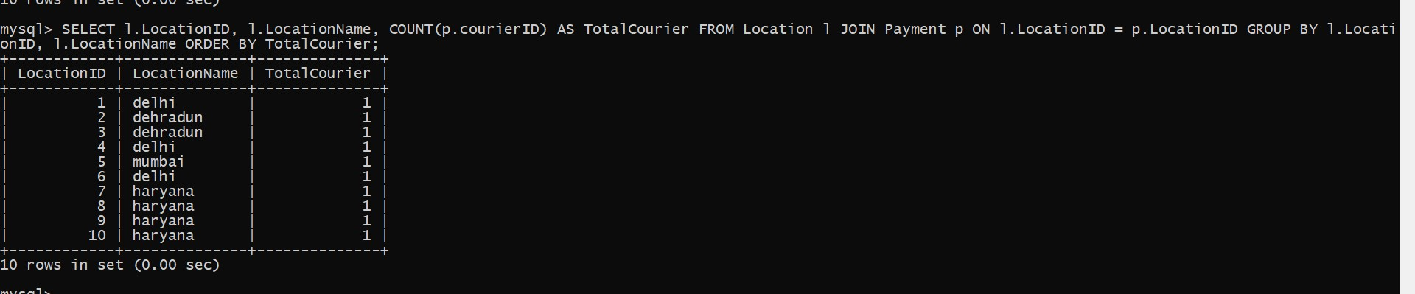

17. Find the courier with the highest average delivery time:

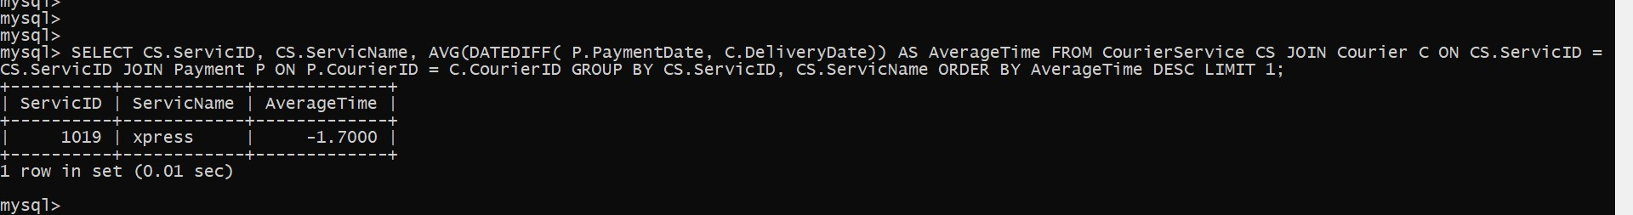

18. Find Locations with Total Payments Less Than a Certain Amount



19.Calculate Total Payments per Location

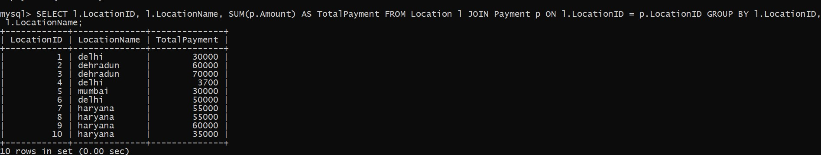

20. Retrieve couriers who have received payments totaling more than $1000 in a specific location (LocationID = X)

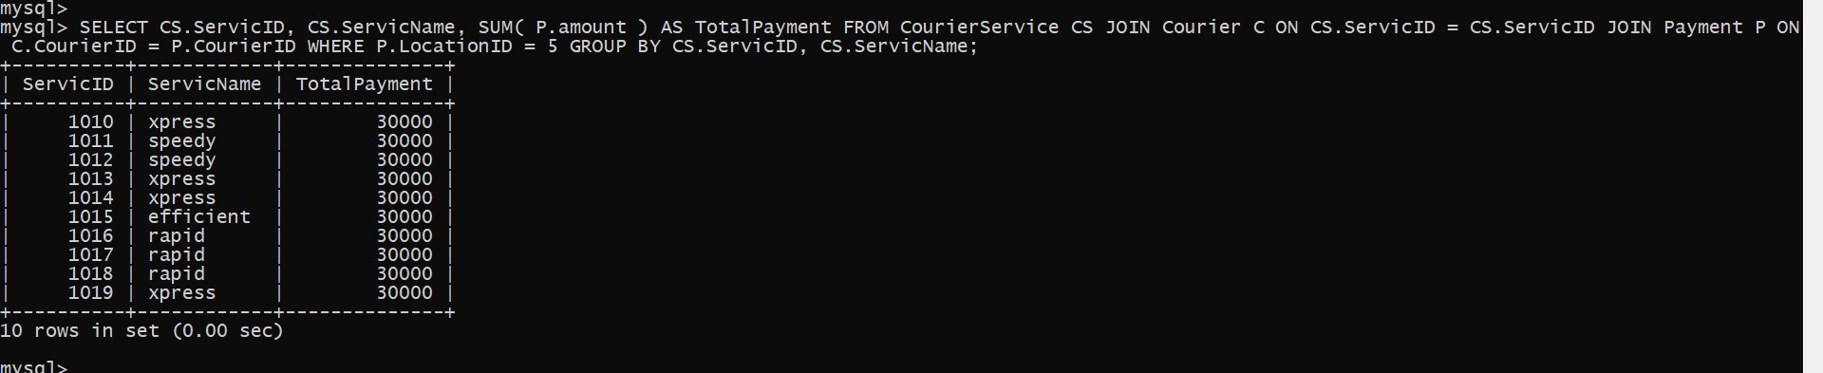

21. Retrieve couriers who have received payments totaling more than $1000 after a certain date (PaymentDate > 'YYYY-MM-DD')



22.Retrieve locations where the total amount received is more than $5000 before a certain date (PaymentDate > 'YYYY-MM-DD')

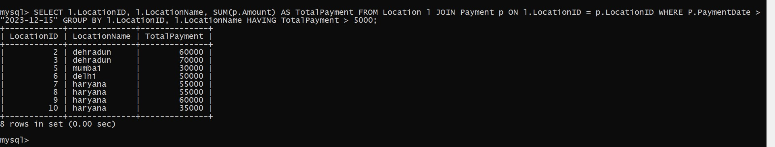

23. Retrieve Payments with Courier Information

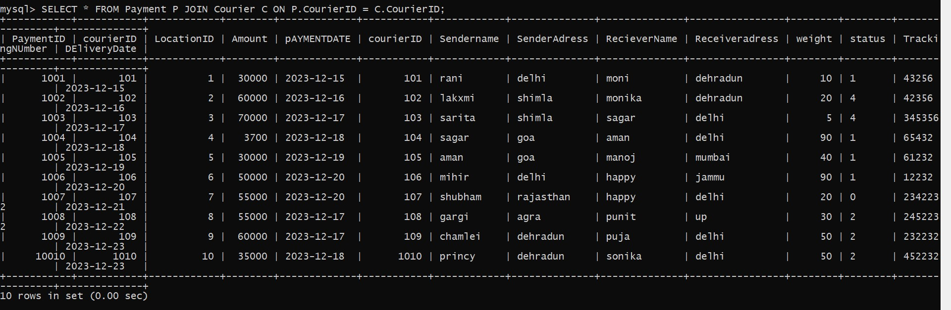

24. Retrieve Payments with Location Information

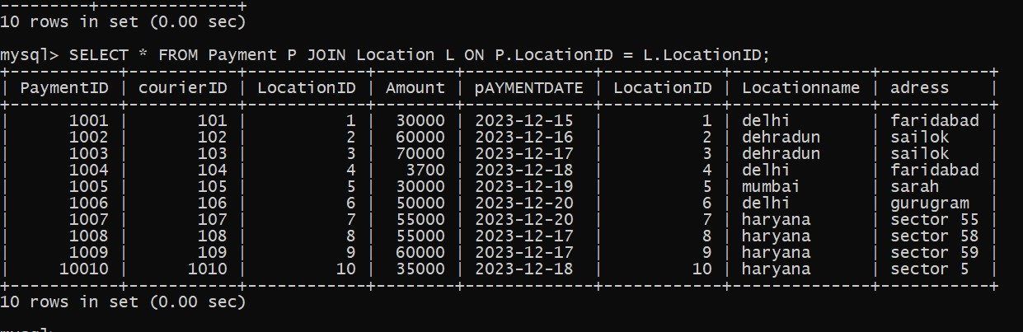

25.Retrieve Payments with Courier and Location Information

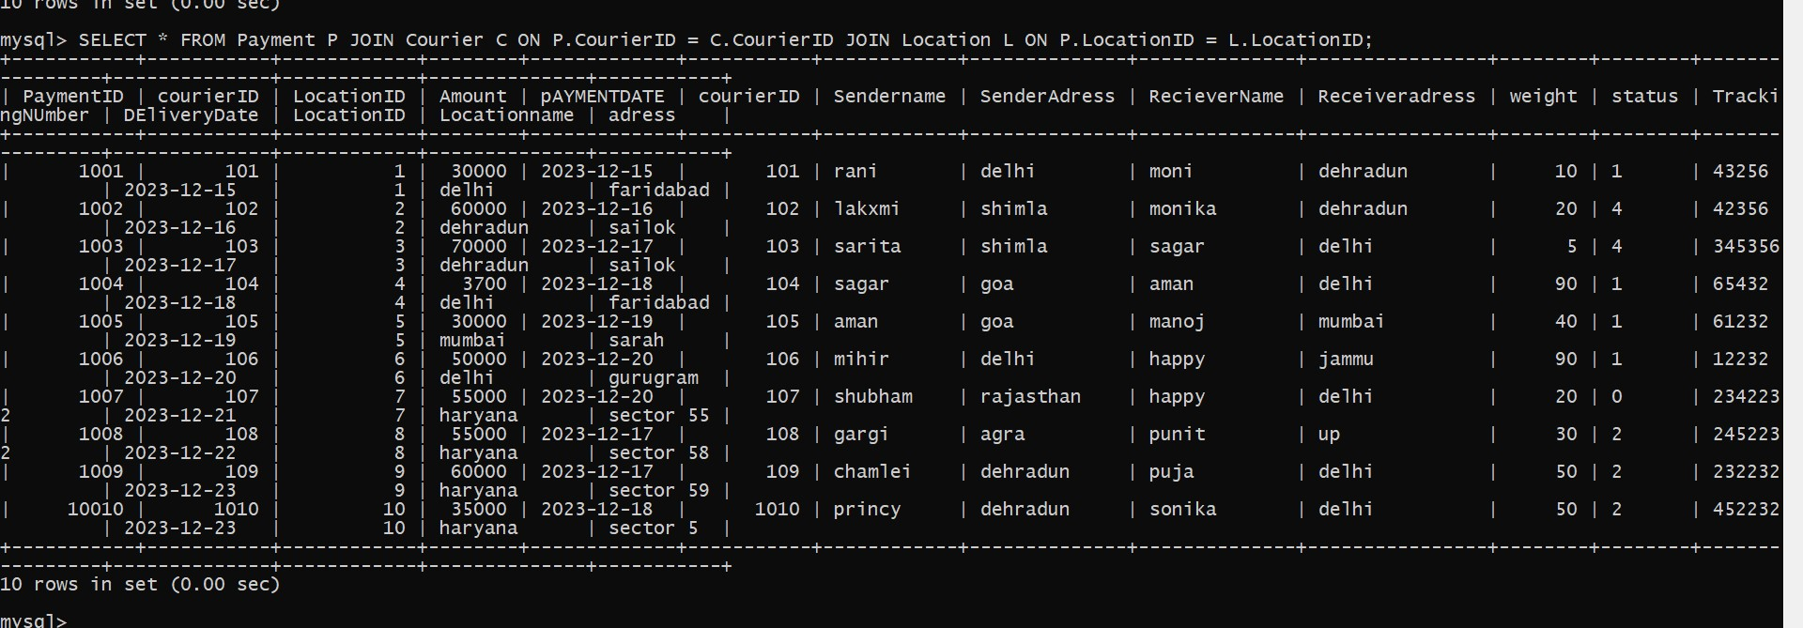

26.List all payments with courier details



27.Total payments received for each courier

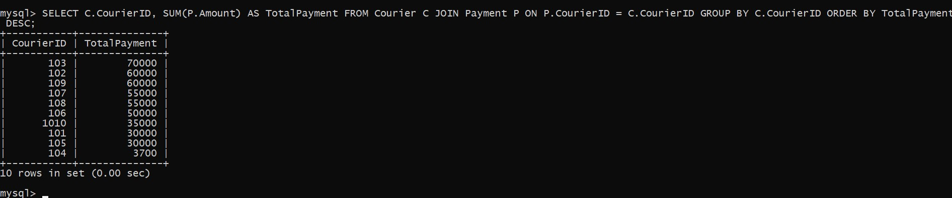

28. List payments made on a specific date

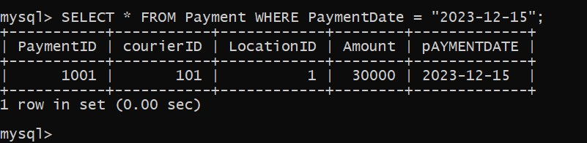

29. Get Courier Information for Each Payment



30. List all users and all courier services, showing all possible combinations.

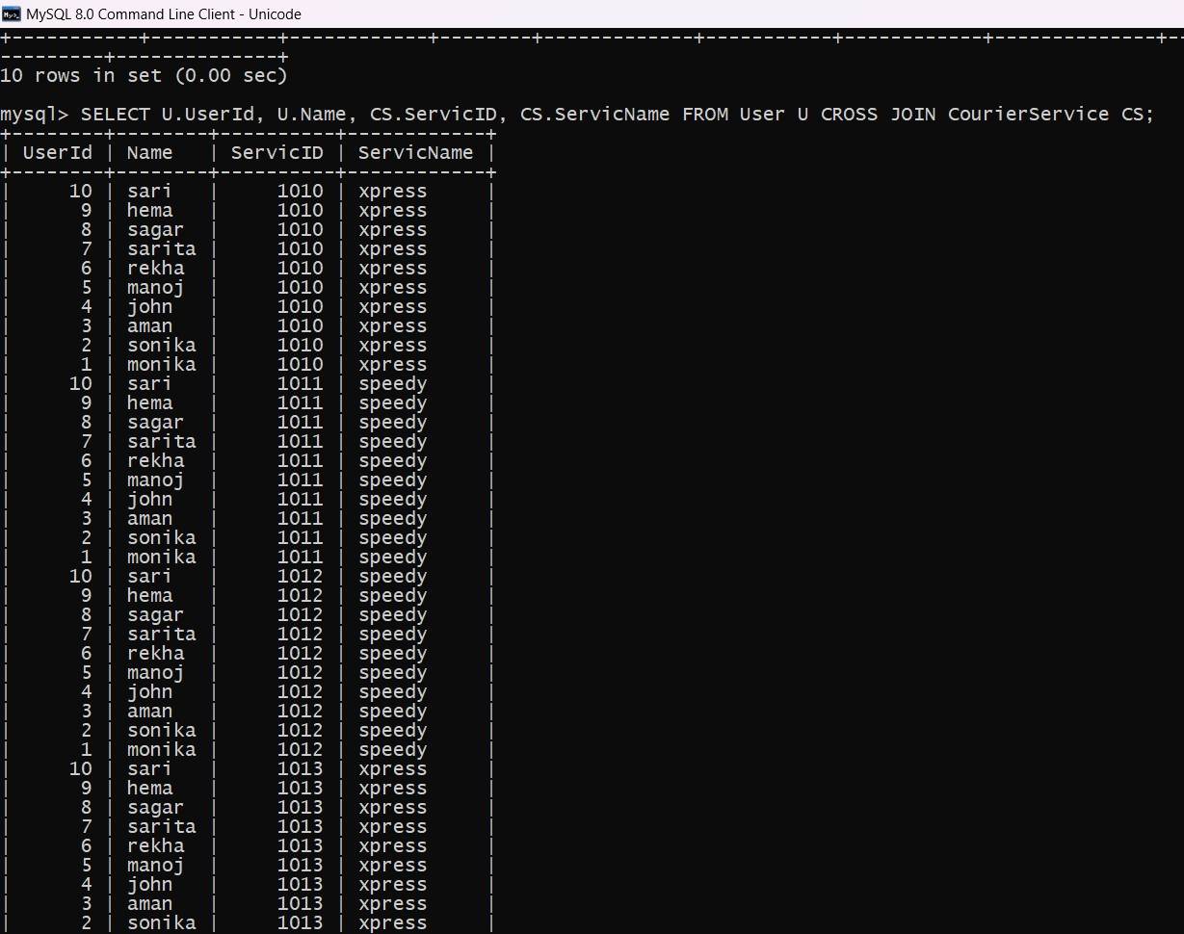

31. List all employees and all locations, showing all possible combinations

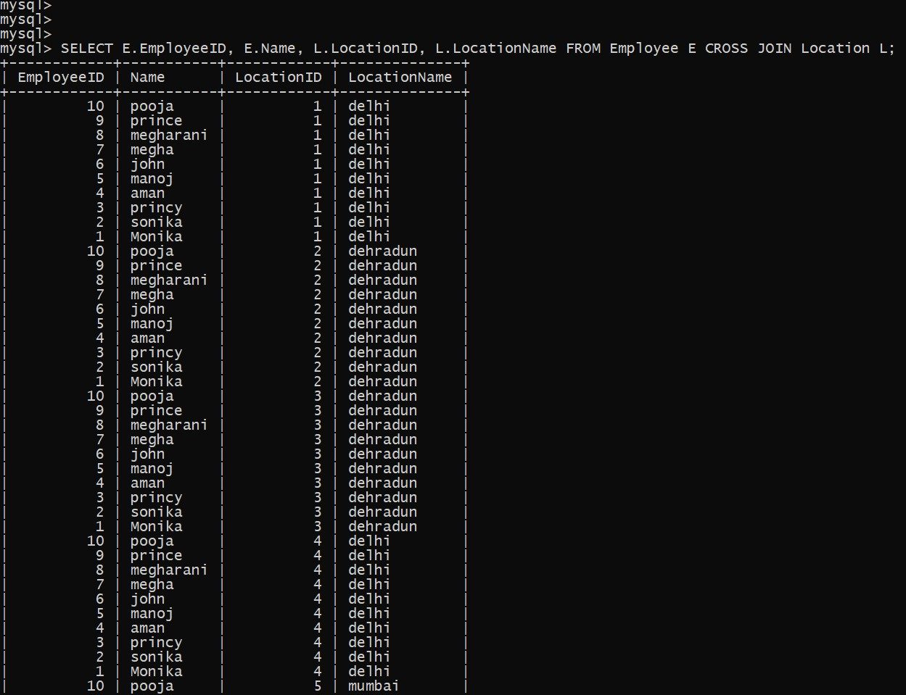

32.Retrieve a list of couriers and their corresponding sender information (if available)

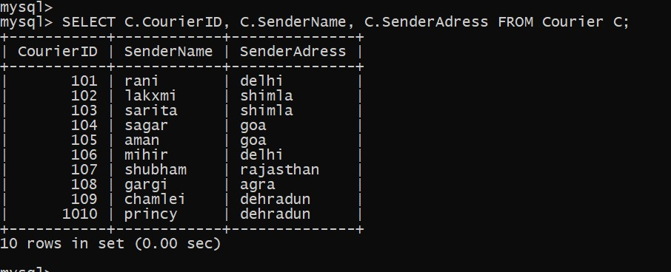

33. Retrieve a list of couriers and their corresponding receiver information (if available)

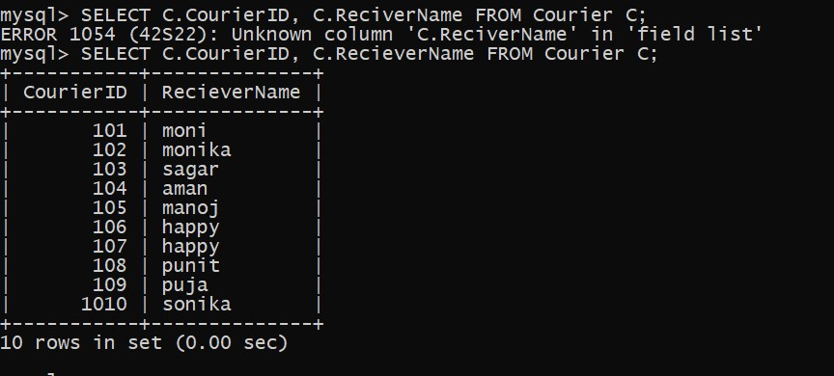

34. Retrieve a list of couriers along with the courier service details (if available)

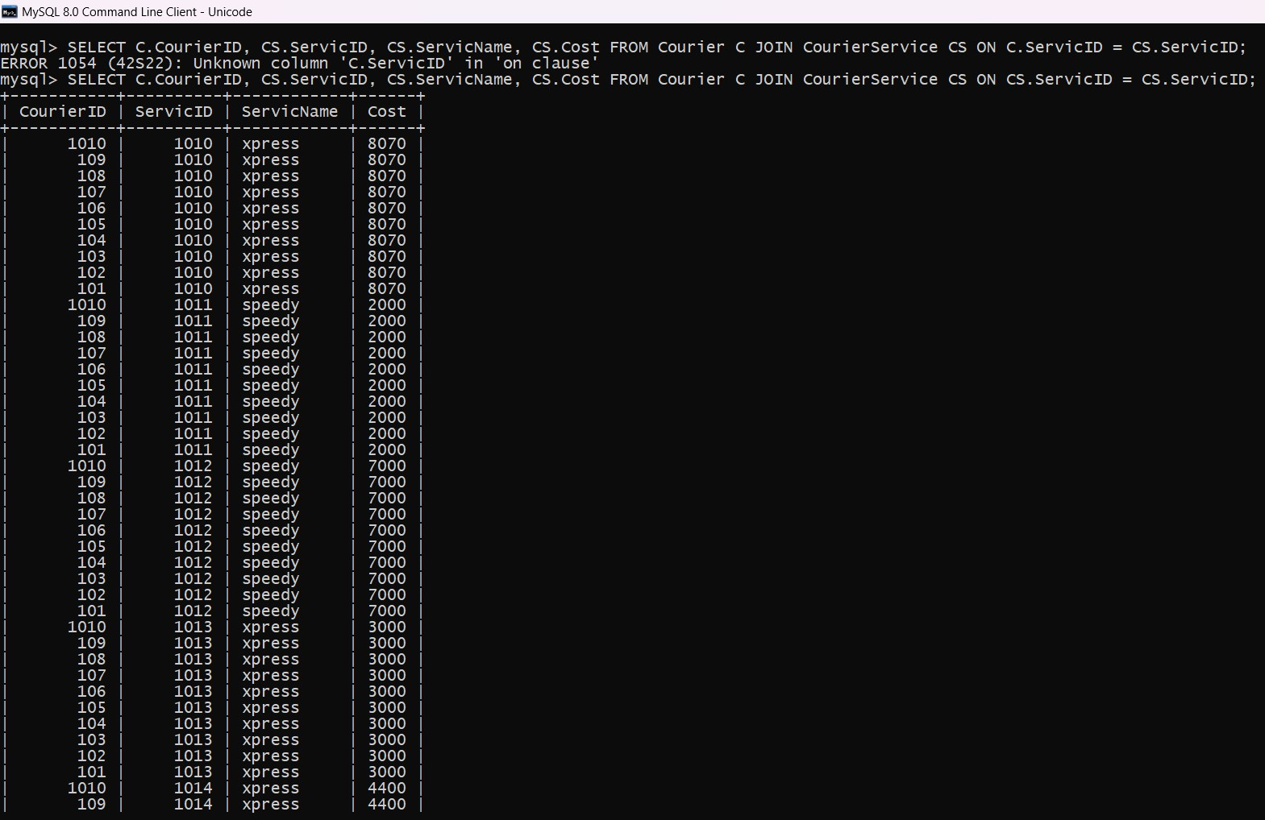

35.Find couriers that were paid an amount greater than the cost of their respective courier services

